* 1. **IOC Surgery**
     1. **Turn on the bead sterilizer.**
     2. Prepare all injectables: Look at the chart above the drug drawer to know what amount to pull for the following: Meloxicam, Induction dose of KX mix, Penicillin, and Saline.
     3. Prepare the ISO chamber by turning it on then pressing “Induction” then “Deliver”. Make sure the tubing isn’t getting pinched anywhere. Let it fill the closed induction chamber for 3-5min. Waiting the full 5min makes your animal go down faster.
     4. After your animal is immobile, you can tilt the box sideways to check if they’re able to still get up. If they can’t; wait for about 30sec then pull them out onto some paper towels for the induction does of KX mix delivered intraperitoneally.
     5. After 10min check on your rat to see if she’s down. Then once she is start shaving her head and make sure it’s tight and clean and football shaped. (if she’s not down in 15min you can give her a boost)
     6. After being shaved, she’ ready for the ear bars. This is hard to do right so always get a second opinion if you aren’t sure that it’s perfect. Now insert the butt plug with Vaseline and tape it with the cloth tape. Turn on the heating pad.
     7. After this, put on eye goop to keep her eyes hydrated. Give a rub on the scalp with alcohol wipes, chlorhexidine or iodine. Then, inject lidocaine into the scalp. In multiple spots if you’re nice. You can also give meloxicam now.
     8. After 5min you’re ready to slice her open. So, take out a scalpel and give a cut that’s about 1.6-1.8cm in length.
     9. Now put the retractors in the bead sterilizer for 60sec and place it into sterile saline. Dry it off and then use it to open the wound so that you can work.
     10. Finally, dry the scalp so that you can mark where to put skull screws.
     11. Using the small drill bit make holes in the skull that are approximately half the size of the tip of the drill bit. Make at least 4 of these. Avoid the suture lines. Please use microscope.
     12. Now take out the screws from the cetylcide and place them in sterile saline. Then dry them out on a kimwipe and prepare to put them in the skull with the screwdriver.
     13. After the screws are tight, make your pocket hole to the end of the coronal suture line near where the craniotomy for GC is located. Make its depth half the length of the spatula. Place a little kimwipe in there so it doesn’t dry out and get stuck.
  2. **Surgical Preparation**
     1. To prepare the needle and IOC for surgical insertion put a 20-gauge needle through the flared end of the IOC tubing.

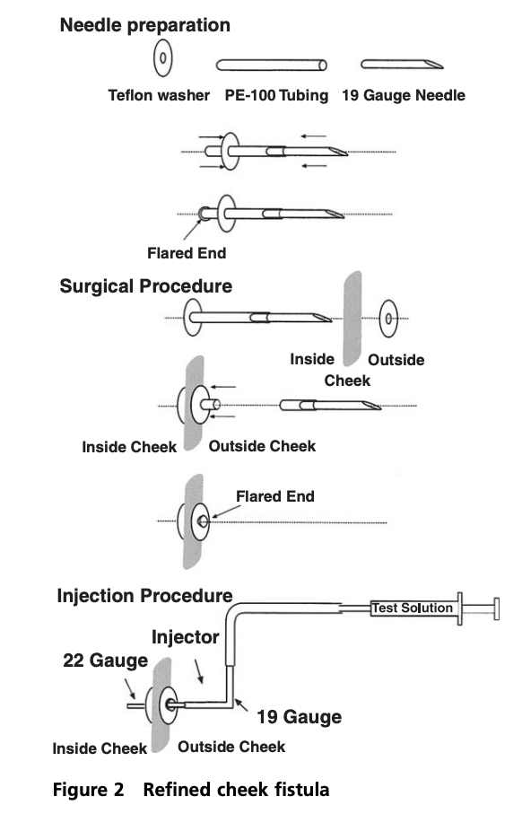

**Washer PE-100 Tubing 20 Gauge Needle**

* + 1. The other end of this is a silicone tube of 1 inch attached to a colder non-valved coupler body 1/16th inch via attaching the silicone tube to thin forceps and putting the point of the forceps into the hole on the barb-side of the coupler and sliding the silicon over onto the barb. This is then secured with VetBond.

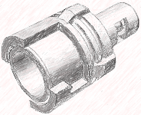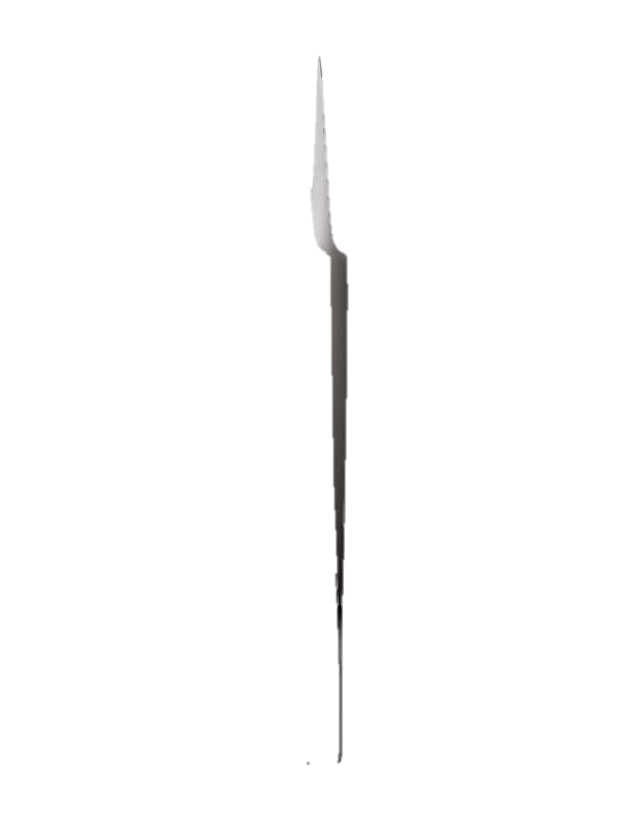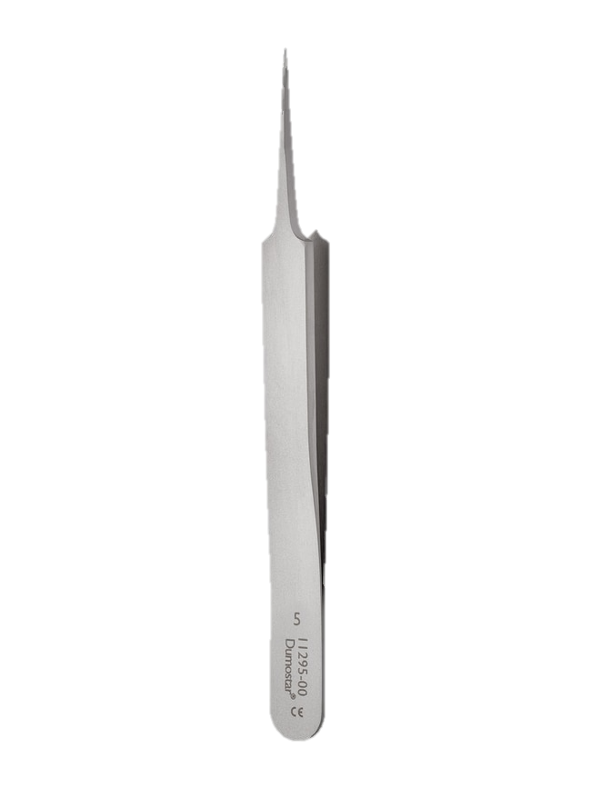

**Forceps Silicone Tube IOC Coupler**

**VetBond goes here!**

* + 1. The insertion should be right next to the second molar M2 between the teeth and the cheek.

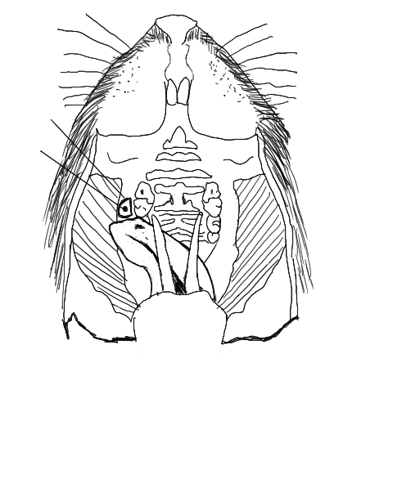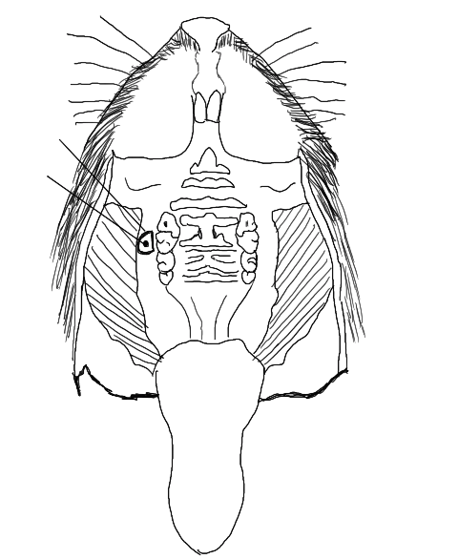

Washer

Washer

IOC opening

IOC opening

* + 1. The inserting of the needle should follow the edge of the skull, underneath the masseter muscle, through the zygomatic arch, and up to the incision on the top of the head where the pocket hole was made. This is quoted 30° angle.

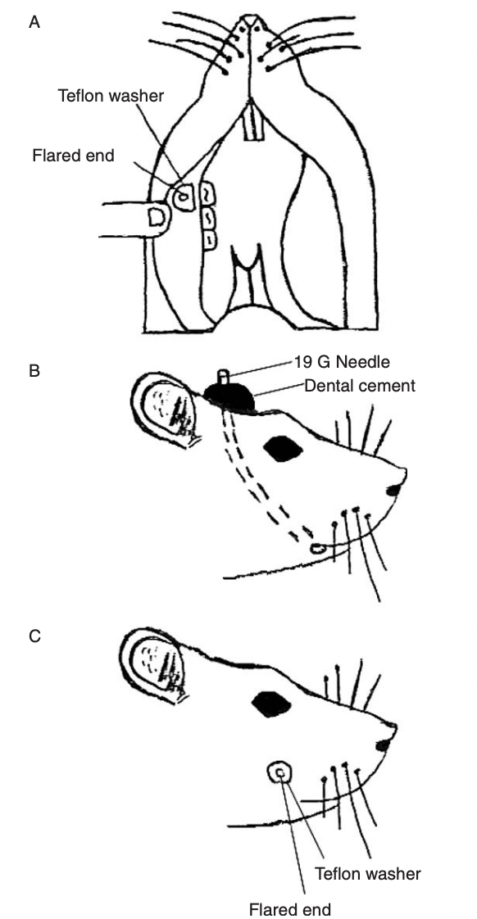

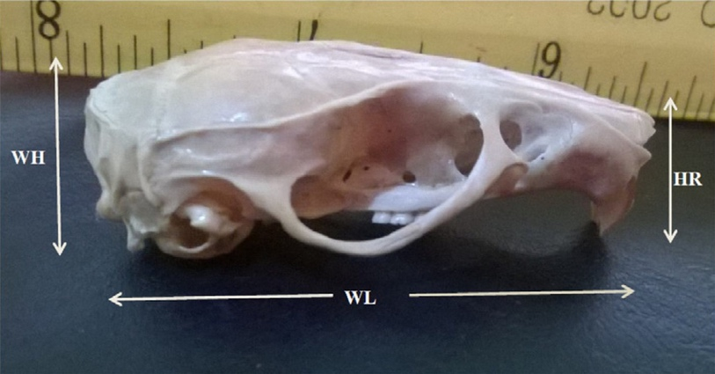

* + 1. Making and plugging up the IOC Pocket hole

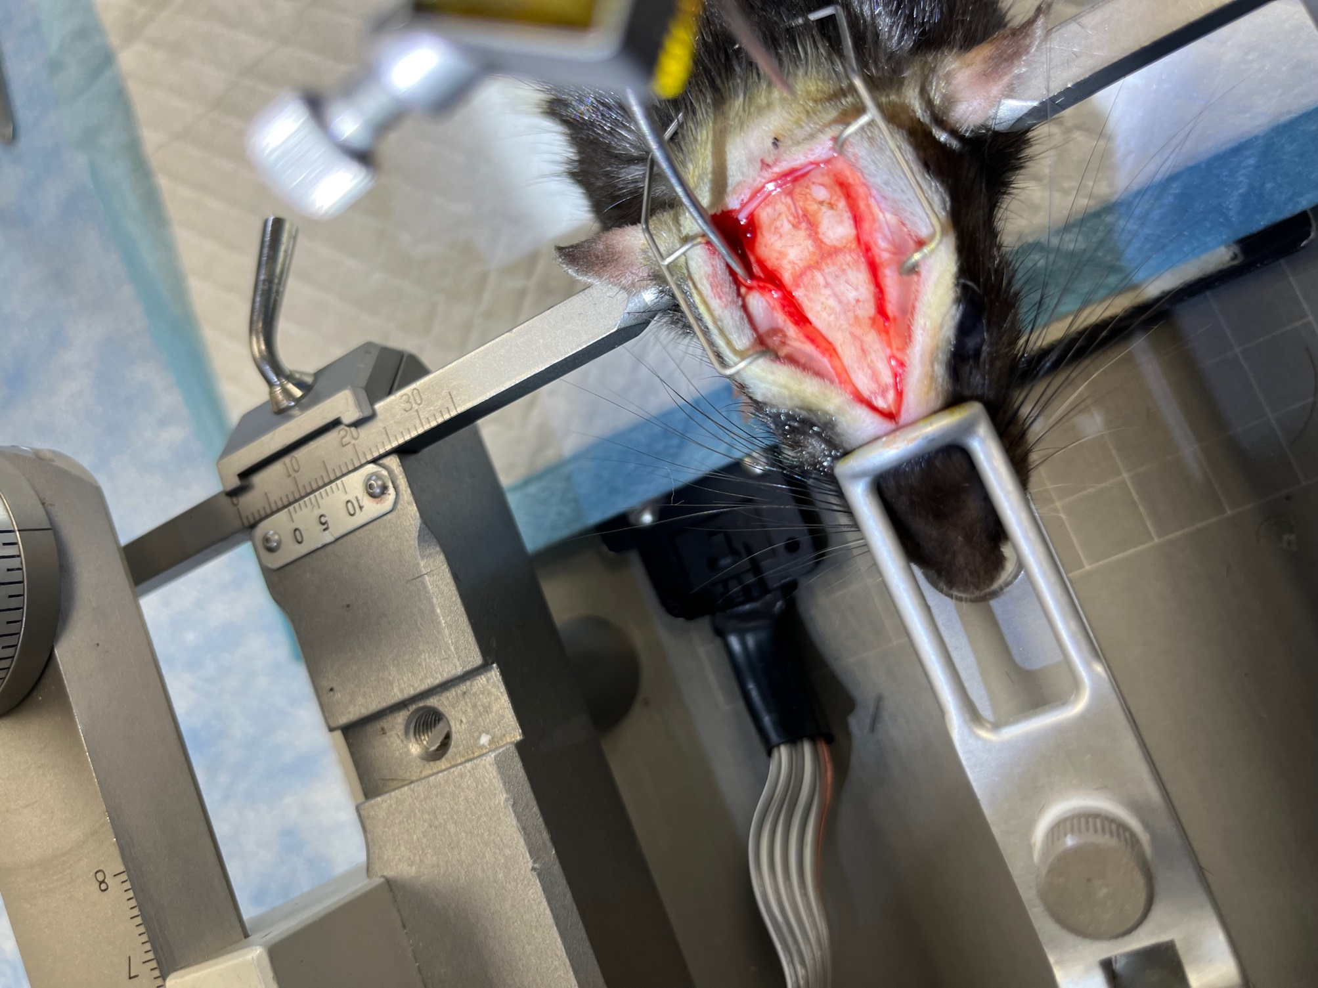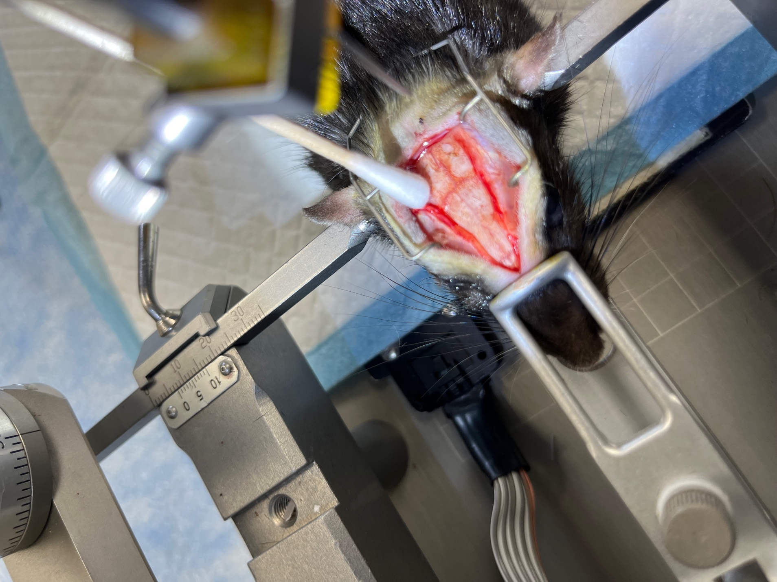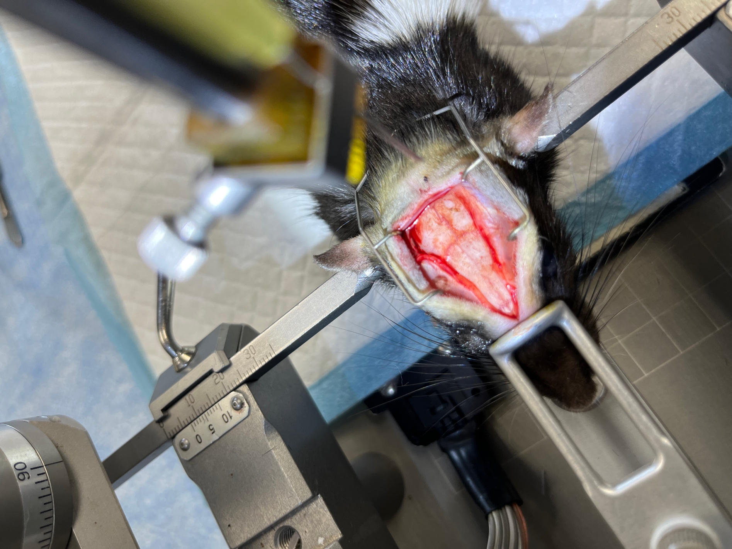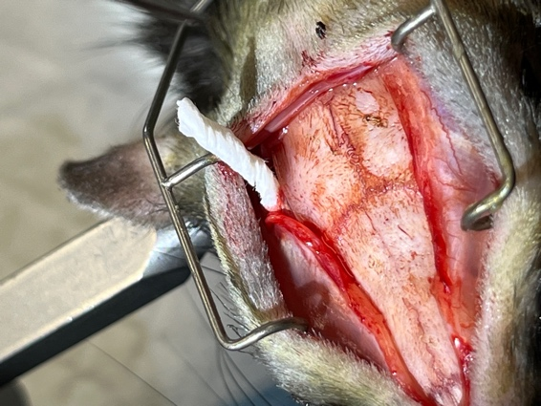

**Making IOC Pocket Cleaning Open Pocket Cover Pocket with Tissue**

* + 1. The pocket hole in the picture above is too posterior and should actually be closer to where the coronal suture meets the ridge of the skull.
    2. Cap for plugging up the IOC coupler and IOC itself once implanted. Use the Male Colder coupler cap attached using epoxy to PE tubing for IOC cleaning to plug up the IOC and keep it clean in-between uses.

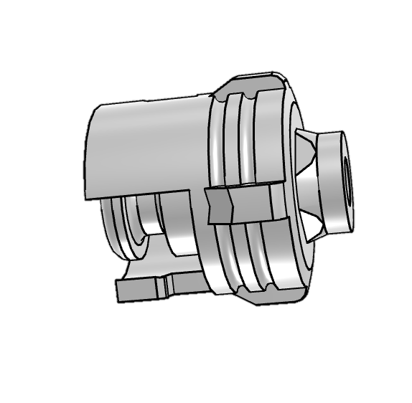

* 1. Inserting the IOC
     1. Opening the mouth with the retractors on the teeth lets you get a nice view of the mouth before inserting the IOC to its home. Keep the tongue out of the way by gently moving it with a swab. Make sure the retractors have been sterilized.
     2. An additional retractor can be used to open the mouth sideways to get a better view.
     3. Use a “guide” backend of the cotton swab to position where you will use the yellow needle to insert the IOC. Make sure the flared end is closest to the yellow tip and not the needle point. Insert such the bevel of the needle is closest to the teeth and that the cut end of the flared end of the IOC is set to be brushed up against the molars.
     4. Insert your needle following the trajectory behind the eye withing the orbital bone and out through your pocket hole. Do NOT wiggle to get through or try to do it twice.
     5. It’s not the end of the world if it doesn’t come out of the pocket hole perfectly but will lead to more inflammation, infection, and discomfort so be cautious.
     6. You can use the spatula to “feel” for the needle too as you insert it but again be careful not to leave your trajectory as the more you go through muscle the more the poor animal can’t use their jaws right.
     7. Once through connect the coupler and silicone sleeve onto the needle and onto the IOC and add a touch of vetbond to join them.
     8. Now double check that IOC flared end is right where you want it because now, you’ll want to remove the needle, pull up the IOC and connector to ensure flush fit with the teeth and start dental cementing the IOC in place WITH the needle inserted through the top so that it ends up straight.
     9. Build up from the bottom while connecting to the screws and up to the tip of the IOC cap covering the little window.
     10. Afterwards, give remaining saline and put bacitracin along the incision site.
  2. Previous Studies on Alternatives
     1. Other related work has proposed intra-cheek cannulas, intraoral cannulas the follow the path in front of the eye up to the head, and some that come out around the scapulae of the rat.
     2. 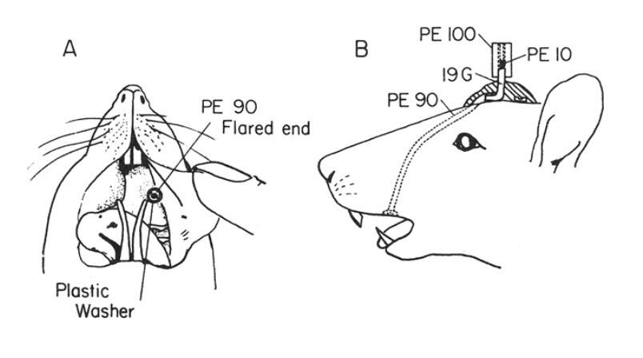Examples below:

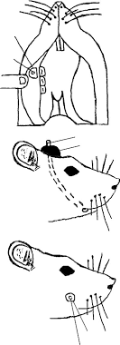

Some work recommends using chlorhexidine a cationic surfactant with broad-spectrum antimicrobial activity to disinfect the IOC during and after surgery. This is considered the “gold standard” in oral antiseptics however it has an acute effect on sodium taste perception but not on quinine although the solution has a slight bitter taste.

* + 1. Cutting washer to fit flush with the teeth.



* 1. APPENDIX: Examples of IOC placements
     1. Here are some photographs of IOC placements in previous rats.

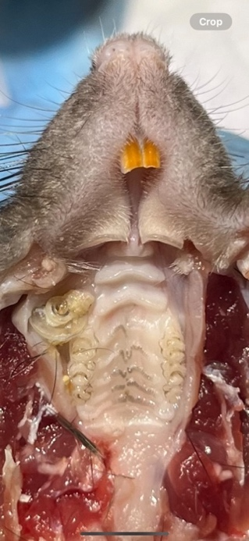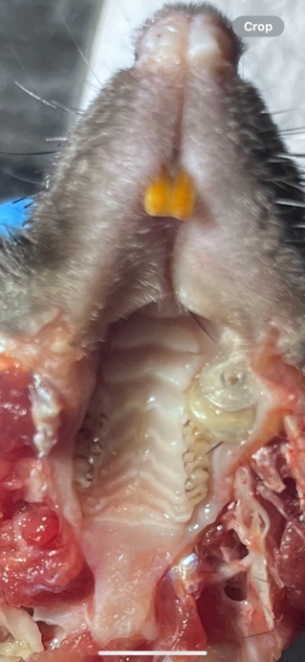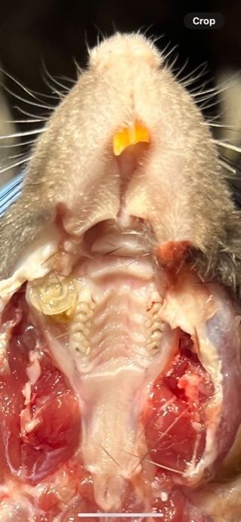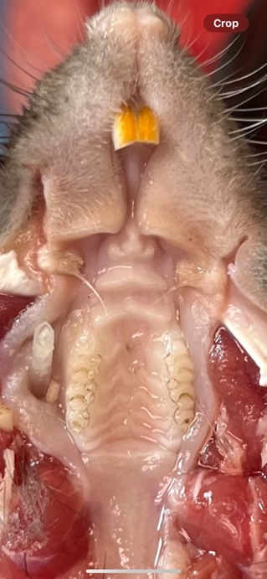

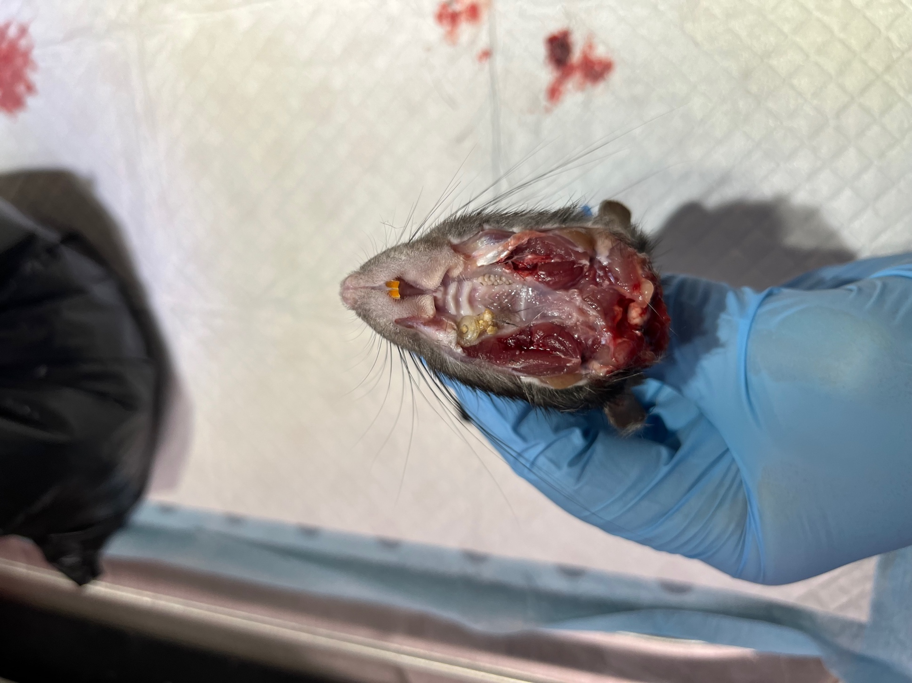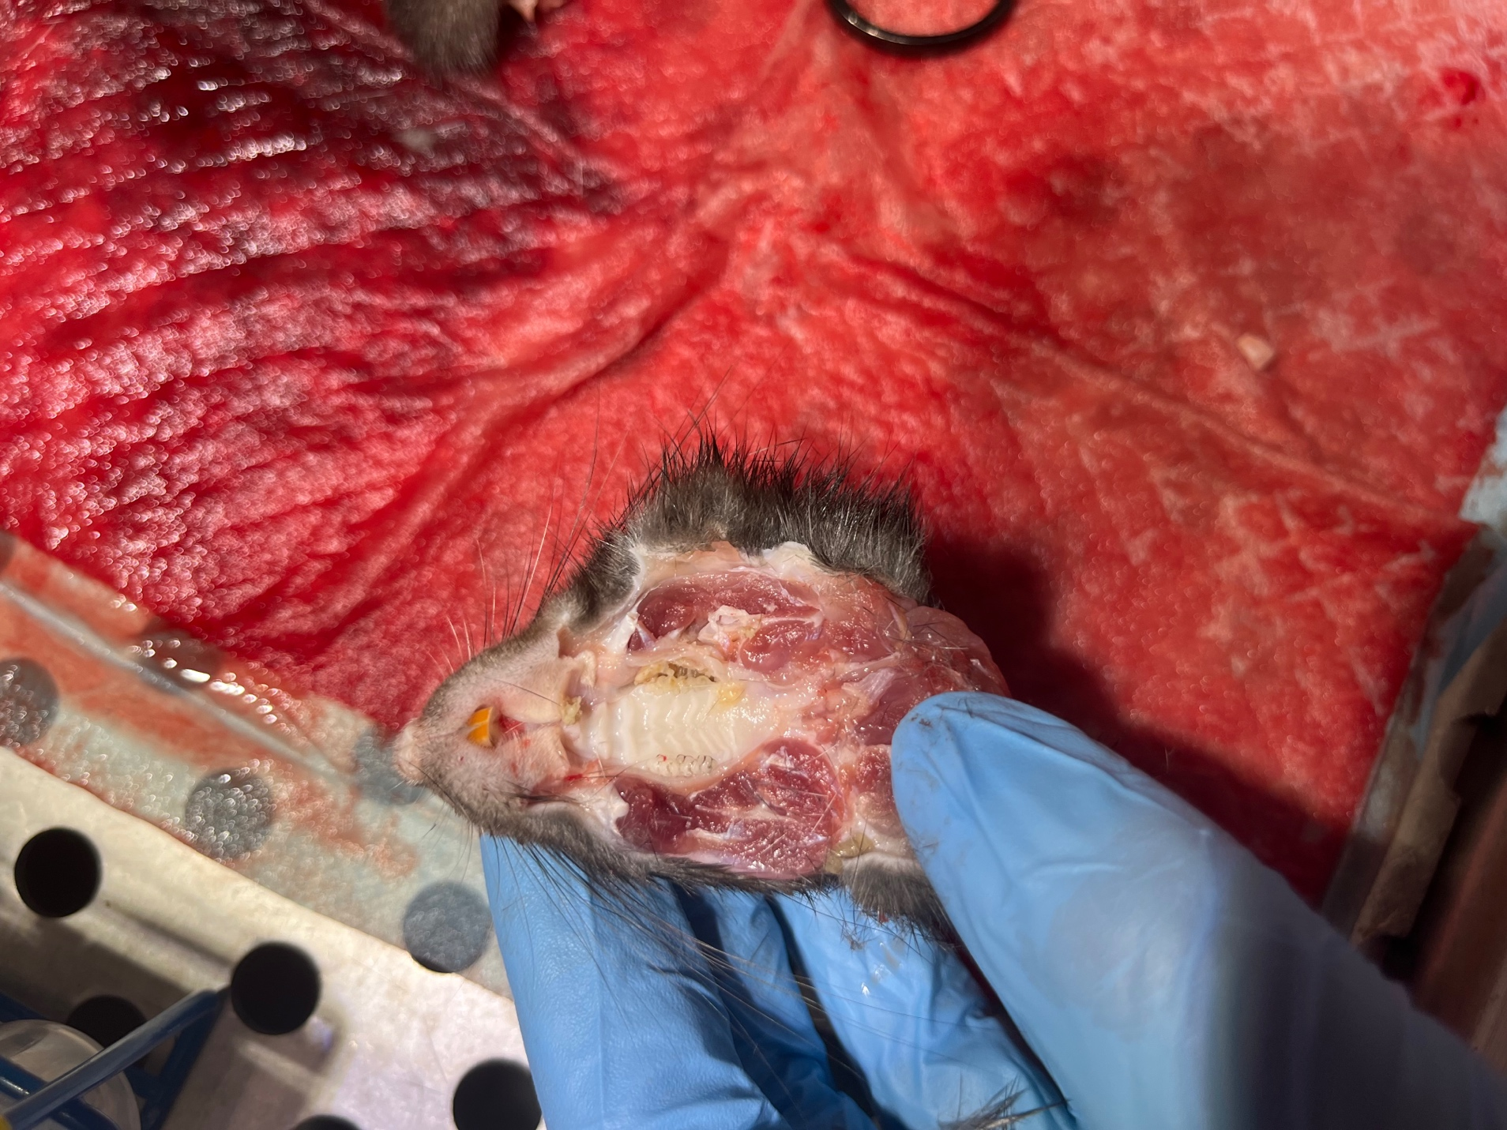

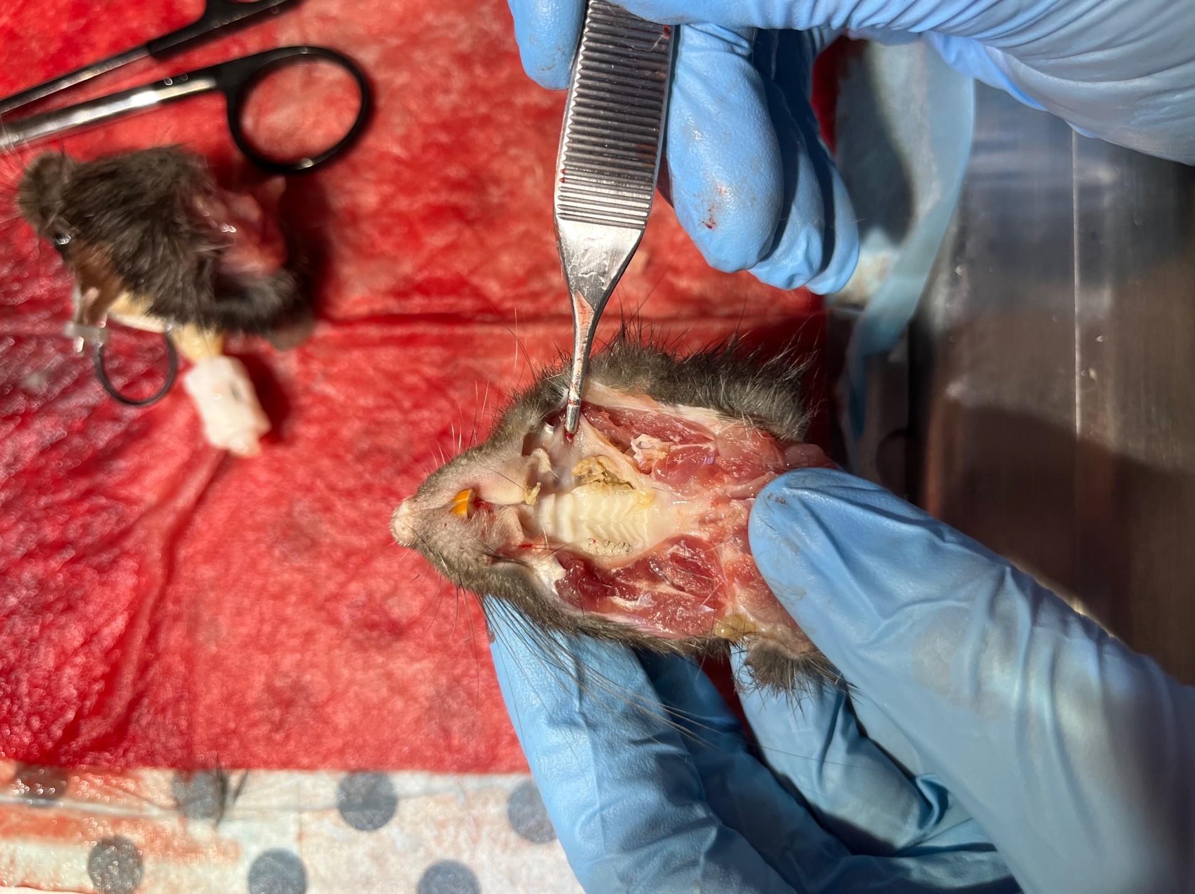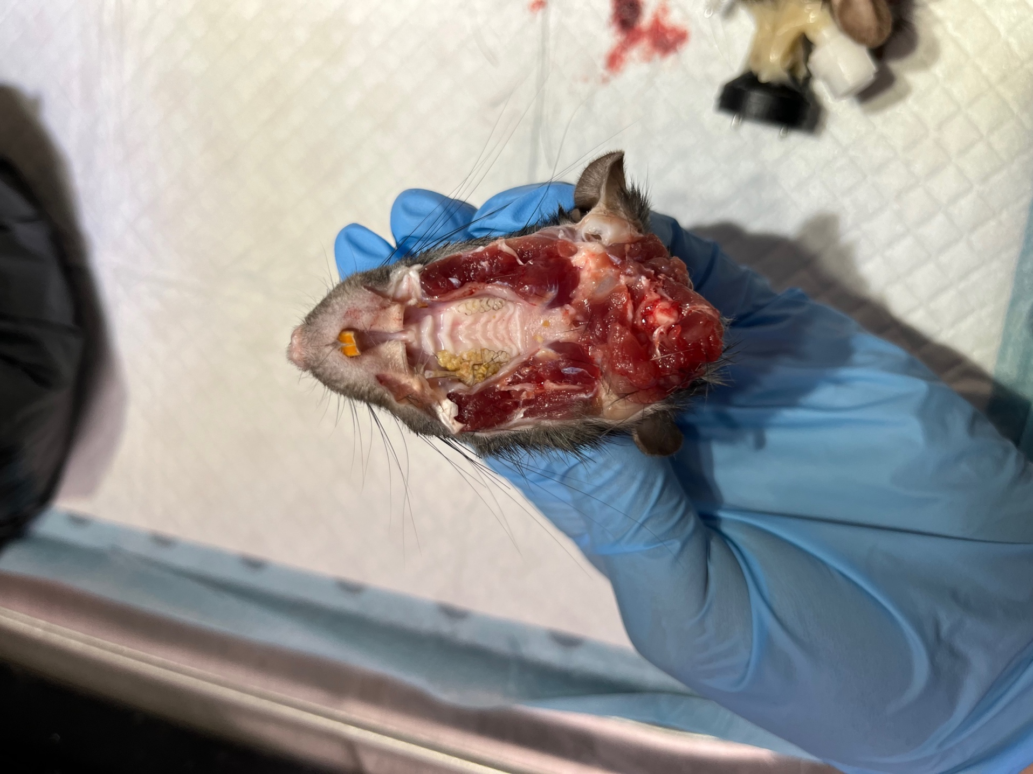

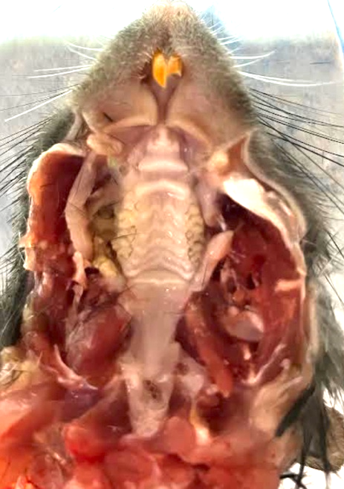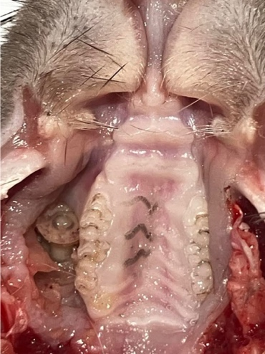

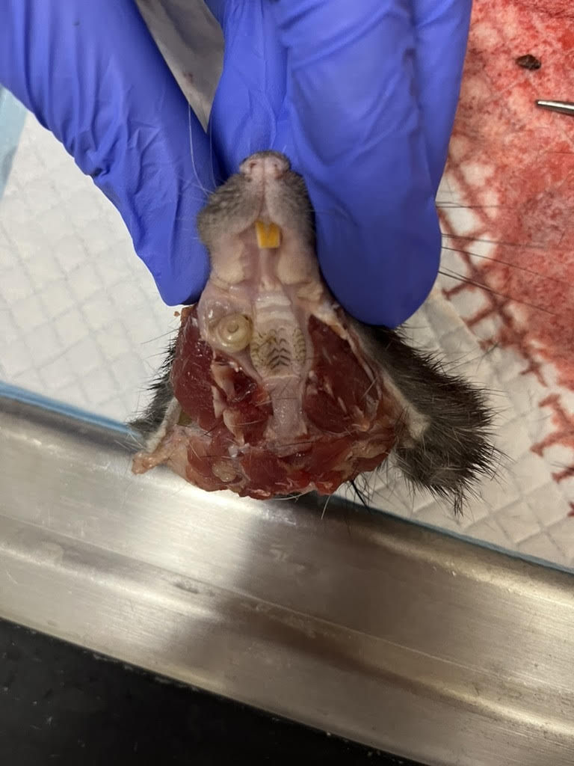

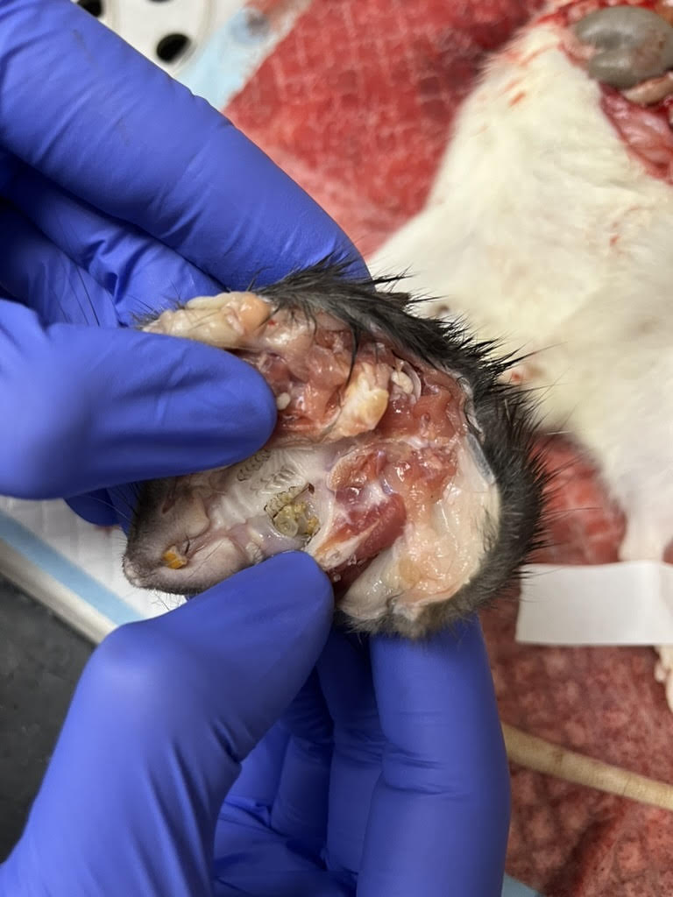

**Ordering Notes for IOC**

|  |  |  |
| --- | --- | --- |
| Colder coupler Male Plug | <https://www.cpcworldwide.com/General-Purpose/Products/Non-Valved/SMC/ID/SMMP> |  |
| Colder coupler female end (1/16th) | <https://www.cpcworldwide.com/General-Purpose/Products/Non-Valved/SMC/ID/SMF01> |  |
| Colder coupler male end (1/16th) | <https://www.cpcworldwide.com/General-Purpose/Products/Non-Valved/SMC/ID/SMM0112> |  |
| Polyethylene tubing | <https://www.a-msystems.com/p-225-polyethylene-tubing.aspx> |  |
| IOC Cleaning Tubing | <https://componentsupplycompany.com/product-pages/ptfe-tubing-sw.php> |  |
|  |  |  |
|  |  |  |
|  |  |  |

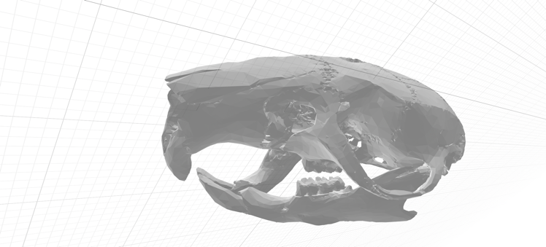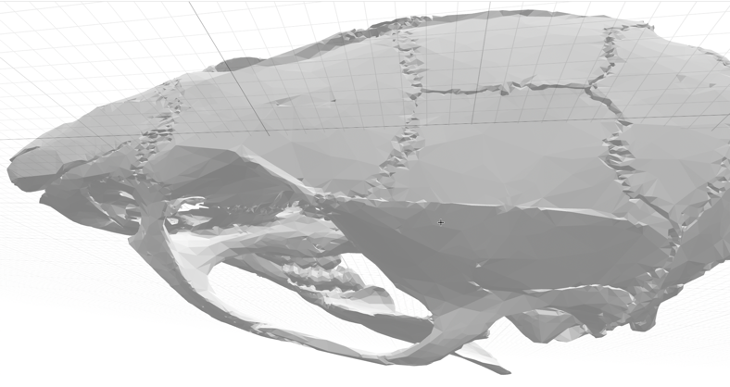

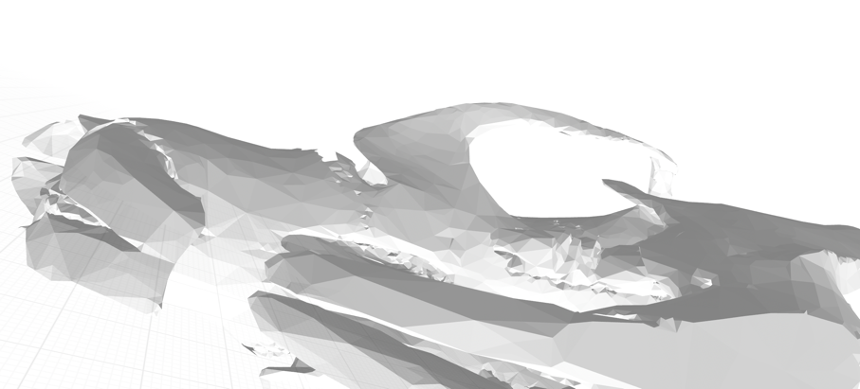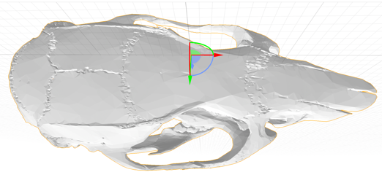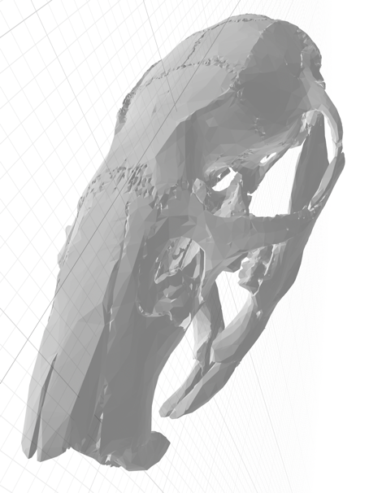Angles of insertion:

IOC Paths

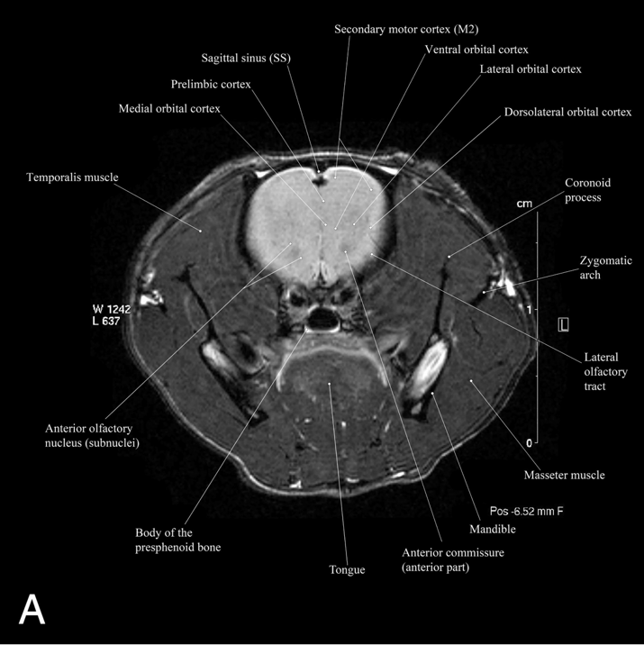

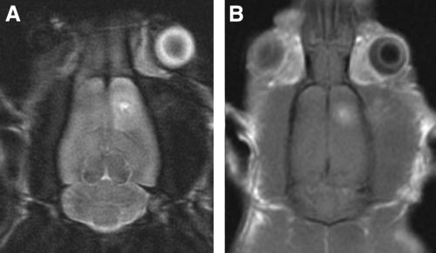

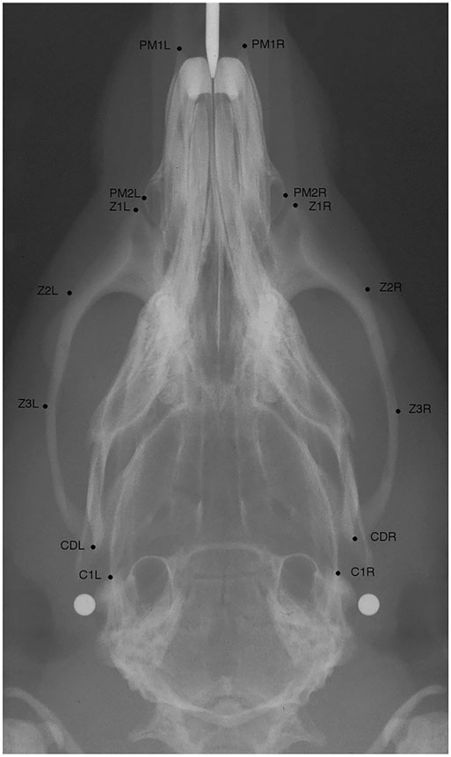

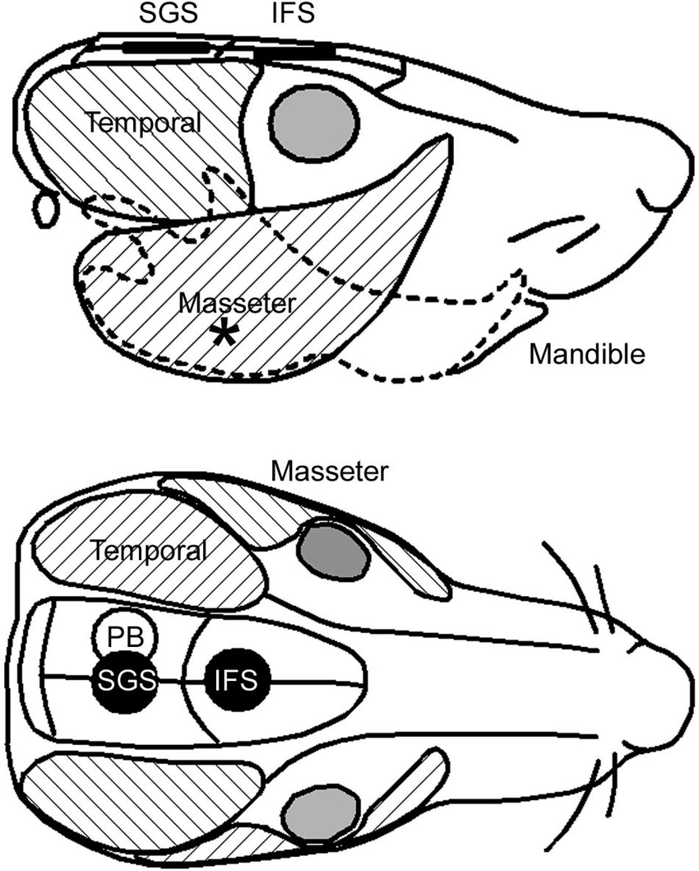

Mouse Whole Body CT

<https://www.imaios.com/en/vet-anatomy/mouse/mouse-whole-body>